}

Guía1. Definición Proyecto APT
Asignatura Capstone

- PARTE I
1. Antecedentes Personales
A continuación, se presenta una tabla en la que debes completar la información solicitada.

Nombre estudiante | Sergio Baeza  Felipe Berrios  Marilyn Correa  Manuel Otaiza  Fabián Quiroz
Rut | 20.282.303-3  20.561.718-3  16.842.516-3  21.551.057-3  21.675.741-6
Carrera | Ingeniería en Informática
Sede | Puente Alto

2. Descripción Proyecto APT
En la descripción debes señalar brevemente el nombre de tu proyecto APT y las competencias del perfil de egreso que vas a poner en práctica. Si en tu carrera están definidas las áreas de desempeño, también menciona a qué áreas de desempeño está vinculado el proyecto.

Nombre del proyecto | AgroTech SaaS
Área (s) de desempeño(s) | Software Development, Database Management, and Information Systems Architecture.
Competencias | Creation of documentation for IT project management.  Construction and programming of a cross-platform mobile software solution.  Modeling and programming of relational databases with asynchronous synchronization.

3. Fundamentación Proyecto APT
A continuación, se presentan distintos campos que debes completar con la información solicitada. Esta sección busca que describas en detalle tu proyecto y justifiques su relevancia y pertinencia.

Relevancia del proyecto APT | Currently, the agricultural and livestock industry faces a critical modernization challenge. Traditional Enterprise Resource Planning (ERP) solutions depend on a continuous internet connection, which is unviable in rural areas and pastures with poor or non-existent cellular coverage. Consequently, workers operate disconnectedly, recording medical and production data on paper. Selecting this topic is highly relevant to our professional field, as it allows us to develop a complex architectural project ("Offline-First") that digitalizes animal traceability and improves managerial decision-making, modernizing a productive sector that urgently requires technological solutions adapted to its geographical reality.
Descripción del Proyecto APT | The project consists of improving the organization and traceability of livestock enterprises by developing "AgroTech SaaS," a cross-platform mobile application. The solution encompasses farm management, clinical records, weight control, and optical QR code reading in the field without relying on internet access. Furthermore, it will feature interoperability with a central cloud server responsible for asynchronously synchronizing the collected data to feed a Business Intelligence (BI) managerial dashboard.
Pertinencia del proyecto con el perfil de egreso | This project is directly related to our graduate profile, as it presents a comprehensive IT challenge requiring the application of critical competencies: requirements analysis and specification (SRS), scalable data model design, software programming with asynchronous synchronization, and quality assurance (QA). These competencies are fundamental to solving the problem at hand, demanding that we manage the project from its initial documentation phase through to the coding and deployment of the final system.
Relación con los intereses profesionales | Our professional interests are strongly linked to creating robust IT systems, data analytics, and developing cloud architectures. The aspects reflected in this project include database integration (SQLite and PostgreSQL) and development using modern languages (React Native and Python). Executing this project brings us closer to the real-world labor market we will face upon graduation, helping us understand how to manage technological solutions from start to finish.
Factibilidad de desarrollo del Proyecto APT | The duration of the semester and the allocated hours allow us to execute the structured planning outlined in our Gantt chart (17 continuous weeks). The required resources for the solution are: Development computers, the React Native framework for the mobile app, Supabase (PostgreSQL) for the central database, SQLite/PowerSync for local persistence, and Python for BI processing. Developing this project is entirely feasible because the problem is well-defined, and the selected tools are familiar to the team, who possess the necessary knowledge for successful implementation.

- PARTE II
4. Objetivos
En este apartado debes definir objetivos generales y específicos del Proyecto APT. Es importante aclarar que los objetivos se deben plantear en forma clara, concisa y sin dar mayores explicaciones, es decir, deben entenderse por sí solos. Se sugiere redactarlos utilizando un verbo en infinitivo, pues ello obliga a precisar acciones concretas.

Objetivo general | Digitalize the management and traceability of the livestock sector through a functional mobile platform in areas without internet access.  Analyze and statistically visualize livestock production data for managerial decision-making.
Objetivos específicos | Facilitate medical and production recording in the field through an "Offline-First" software architecture.  Streamline animal identification by reading QR codes linked to technical datasheets.  Asynchronously synchronize local data to a centralized cloud database.  Process and graph key performance indicators (KPIs) on the dairy and meat yield of the farms.

5. Metodología
En el siguiente apartado deberás describir la metodología, propia de tu disciplina, que utilizarás para resolver el proyecto APT antes descrito, incluyendo las etapas y métodos de trabajo.

Descripción de la Metodología
To build the AgroTech SaaS platform, we will use the Classic Methodology (Waterfall Model). This structured approach is the most suitable for our project, as it allows us to maintain strict control over the software's scope, budget, and quality through well-defined chronological phases. In this methodology, each stage depends on the completion, documentation, and formal approval of the previous one, which minimizes errors during the programming phase.
The work stages structured under this classic approach are:
- Planning Phase: Definition of project limits, budget (WBS Matrix), and milestone schedule (Gantt Chart).
- Requirements Analysis Phase: Detailed technical specification of the system's 27 functional and non-functional requirements (SRS Document) and Use Cases.
- Design Phase: Modeling the database architecture (ERM) and graphically creating the mobile interfaces (UI Mockups).
- Development (Implementation) Phase: Source code programming in React Native and backend construction (Supabase/Python) strictly based on the designs approved in the previous phase.
- Testing Phase (QA): Technical verification of the finished software by executing the test matrix, forcing network failures to validate Offline persistence.
- Deployment and Closure: Migration to production and delivery of the documented operational system.
To execute this methodology efficiently, our team (IngeTeam) has divided responsibilities according to the following performance areas:
- Marilyn Correa (Project Manager): In charge of planning, time management, budget control, and official documentation.
- Fabián Quiroz (Programmer Analyst): In charge of programming the mobile application, the backend, and the Business Intelligence (BI) module.
- Manuel Otaiza (DB Administrator): Responsible for the relational design, modeling, and connection of the databases (PostgreSQL and SQLite).
- Felipe Berríos (Designer): In charge of the user experience design (UX/UI) and the visual layout of the application.
- Sergio Baeza (QA and Testing): In charge of software quality assurance, test design, and execution of bug reports.

6. Evidencias
A continuación, describe qué evidencias serán evaluadas en el informe de avance y en el informe final de tu proyecto APT. Estas evidencias deben ser acordadas con tu docente. Se entenderá por evidencia los productos que se desarrollen durante el proyecto y cuyo propósito sea visibilizar o documentar cómo se ha implementado el trabajo.

Tipo de evidencia (avance o final) | Nombre de la evidencia | Descripción | Justificación
Progress | Project Charter | Initial document defining the scope, objectives, project team, and budget. | Formalize the project's start and understand the stipulated budget ($21,529,600 CLP) and time limits.
Progress | Software Requirements Specification (SRS) | Document detailing the 27 functional and non-functional system requirements. | Show the technical proposal and establish a non-negotiable guide of what must be programmed.
Progress | Extended Use Cases | Document describing the step-by-step interactions of the user (rancher, veterinarian, etc.) with the system. | Present and understand the user's logical behavior regarding each app functionality.
Progress | UI Mockups | Graphical description of the project (visual mockup) with all application views. | Visually validate the design and usability of the mobile app before coding.
Progress | WBS Matrix and Gantt Chart | Cost breakdown structure by man-hours and the project's time schedule. | Organize dates, assign responsibilities, and economically justify the development.
Final | Testing Matrix (QA) and Fault Tolerance | System quality testing execution report, including simulated internet outages. | Empirically demonstrate that the Offline-First architecture works flawlessly without data loss.
Final | 100% System Development | Delivery of the source code and functional AgroTech SaaS mobile application. | Deliver the final product that solves the stated problem.

7. Plan de Trabajo
En la siguiente tabla define la planificación de tu Proyecto APT de acuerdo a lo requerido.

Competencia o unidades de competencias | Nombre de Actividades/Tareas | Descripción Actividades/Tareas | Recursos | Duración de la actividad | Responsable | Observaciones
IT Project Management | Planning Phase | Define the project charter and structure the budget in the WBS. | Computers and documents. | Weeks 1 and 2 | Marilyn Correa | Facilitator: The problem is clearly defined by the team.
Software Engineering | Analysis and Design Phase | Define requirements (SRS), use cases, and data architecture. | Computers, Office, modeling tools. | Weeks 3 and 4 | Felipe Berríos and Manuel Otaiza | Difficulty: Ensuring all screen flows are logically connected.
Programming and Database | Development Phase | Build the mobile app, backend, and local/cloud persistence system. | Computers, React Native, Supabase, Python. | Weeks 5 to 13 | Fabián Quiroz and Manuel Otaiza | Difficulty: Implementing an asynchronous algorithm that prevents data collisions after days without internet.
Quality Assurance | QA Testing | Execute test plans forcing errors and network drops. | Testing smartphones (Android). | Weeks 14 to 16 | Sergio Baeza | Facilitator: Having previously documented use cases.
IT Project Management | Implementation and Closure | Delivery of the functional system, cloud deployment, and project closure. | Computers and cloud servers. | Week 17 | Entire team | Provides a technical and formal closure to the product development process.

8. Carta Gantt
Busca un formato de Carta Gantt que te acomode y organiza en este las actividades planificadas en el punto anterior considerando el periodo asignado para el desarrollo de tu Proyecto APT. Debes mantener la temporalidad del periodo académico en el desarrollo de las tres fases que contempla la Asignatura de Portafolio de Título.
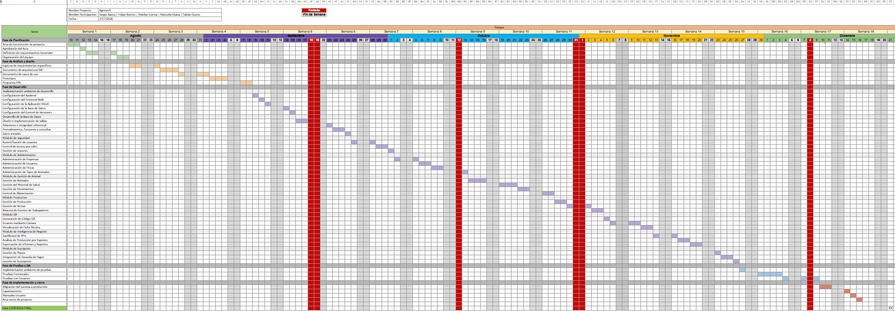

Link: Carta Gantt

